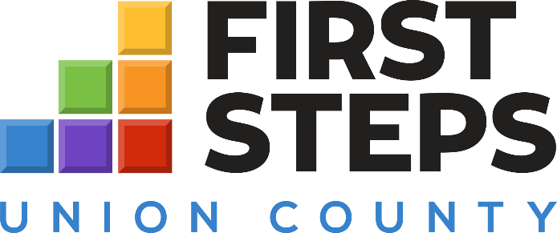

🖇️ Program Assistant (Work Study Position – USC Union)
Organization: Union County First Steps
Location: Union County, SC
Position Type: Work Study / Part-Time
Union County First Steps is seeking a motivated Program Assistant (Work Study) through USC Union to provide administrative and program support. This is an excellent opportunity for a student interested in early childhood education, nonprofit administration, or community engagement.
Responsibilities:
- Assist with office and program coordination tasks.
- Support events, workshops, and community outreach initiatives.
- Help maintain program files, databases, and communications.
- Provide general support to the First Steps staff.
Qualifications:
- Must be an enrolled USC Union student eligible for the Federal Work Study Program.
- Excellent communication, time management, and computer skills.
- Interest in early childhood education or community-based programs preferred.
Compensation: contact your Financial Aid Director for more information
To Apply:
Submit your resume to nicoleglenn@unionfirststeps.org with “Program Assistant Work Study” in the subject line.

