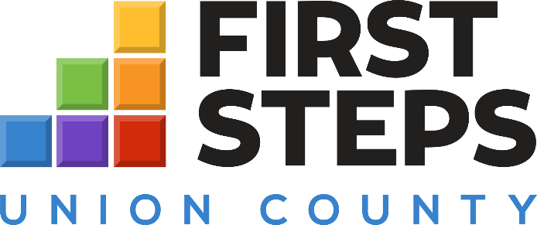

🌟 Communications & Early Childhood Outreach Intern (Part-Time)
Organization: Union County First Steps
Location: Union County, SC
Position Type: Internship / Part-Time
Union County First Steps is offering a part-time Communications and Early Childhood Outreach Internship for a creative and community-minded student or young professional. This role focuses on promoting early childhood programs, family engagement events, and public awareness initiatives.
Responsibilities:
- Assist in developing social media content, flyers, and outreach materials.
- Support the coordination of community events and workshops.
- Capture stories, photos, and data to highlight program impact.
- Collaborate with staff on public relations and communication strategies.
Qualifications:
- Pursuing or recently completed a degree in Communications, Early Childhood Education, Marketing, or a related field.
- Strong written and verbal communication skills.
- Experience with social media management and basic design tools (Canva, etc.) preferred.
- Passion for early childhood development and community engagement.
Compensation: nonpaid position
To Apply:
Send your resume and a brief cover letter to nicoleglenn@unionfirststeps.org with “Communications & Outreach Intern” in the subject line.

